PART A
(PART A: TO BE REFFERED BY STUDENTS) Experiment No.05

A.1—Aim:
To simulate following scenarios using Packet tracer software:
- LAN connection with two router configurations
- Configure WEP security between wireless end devices like smartphone, printer, laptop, tablet etc and a wireless access point

A.2--- Prerequisite:
Basic understanding of internetworking devices

A.3--- Outcome:
After successful completion of this experiment, students will be able to:
- Familiarity of the packet tracer software
- Identify the right devices and cables for building networks
- Know the difference in wired and wireless configurations

A.4--- Tasks:

Perform the following simulation activities:
- Simulate a simple LAN connection with two router configurations
- create two LANs
- connect one router to each LAN
- connect the two routers
- make logical connections among the devices
- verify the connectivity of the network
- See the simulation of sent and received packet using simple and complex PDU
- Simulate a simple wireless network

- Configure a network having one end device, one switch and one router
- Configure a wireless access point and connect few wireless end devices to it
- Connect wireless access point to the router
- make logical connections among the devices
- verify the connectivity of the network
- See the simulation of sent and received packet using simple and complex PDU

Save the file and name it as CN_EXP5_your Roll no_Batch No.

(PART - B)

(TO BE COMPLETED BY STUDENTS)

(Students must submit the soft copy as per following segments within two hours of the practical.
The soft copy must be uploaded on the Blackboard or emailed to the concerned lab in charge faculties at the end of the practical in case there is no Black board access available)

Roll.No. : | Name:
Sem/Year : | Batch:
Date of Experiment : | Date of Submission:
Grade --

B.1: Procedure of performed experiment
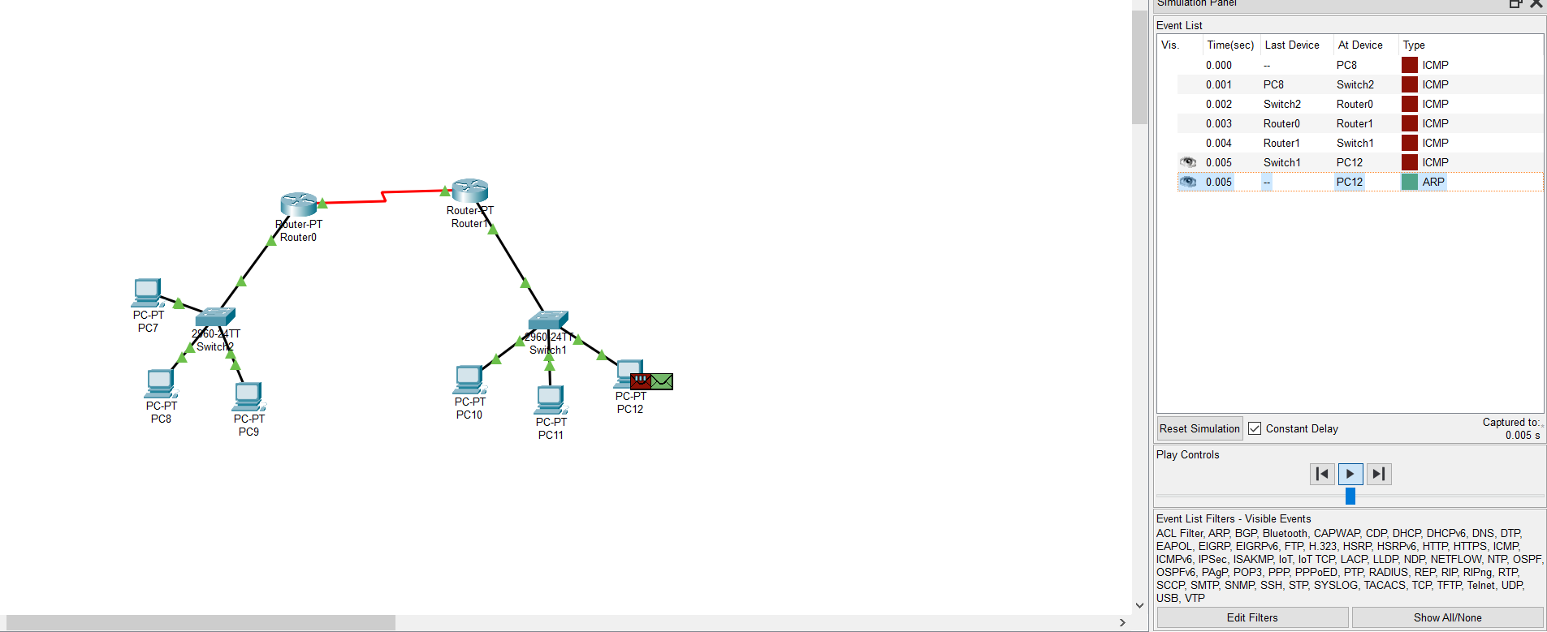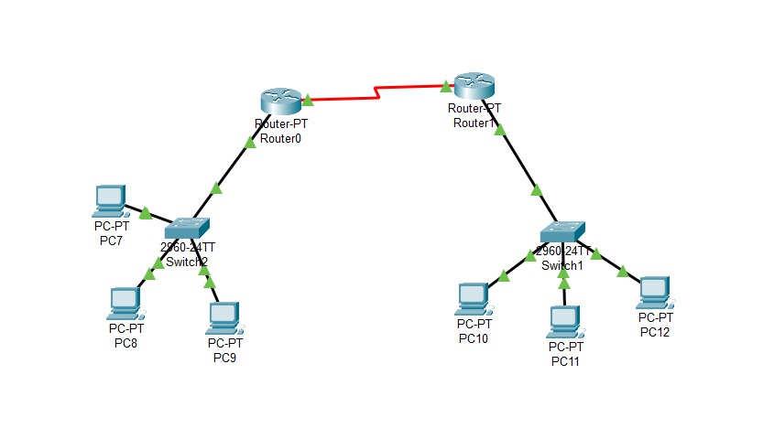

B.2: Observations and Learning’s:
(Students are expected to comment on the output obtained with clear observations and learning for each task/ sub part assigned)

B.3: Conclusion:
(Students must write the conclusion as per the attainment of individual outcome listed above and learning/observation noted in section B.2)

B.4: Questions of Curiosity:

- For the simple and complex PDU added in the simulation mode, view the contents of the PDU and analyse the information (add screenshots)
- Use event list to see PDU information
- View the information of the first ICMP PDU packet from the PC.
- Observe the information in the OSI Model tab
- click the Outbound PDU Details tab. Notice that this tab shows details of the protocol headers
- Explore the contents of other PDUs listed in the Simulation Panel and review the information that is available in each.

